Place Management
An International Review
Professor Cathy Parker
Manchester Metropolitan University
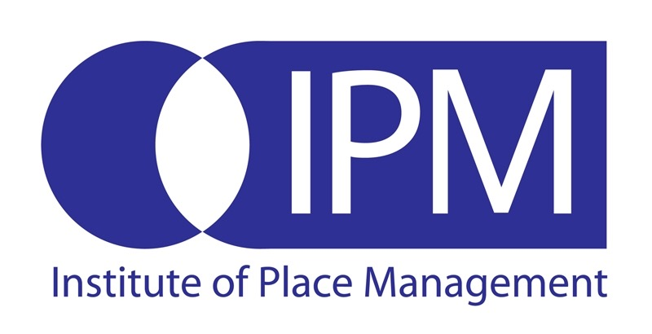

Place Management : An International Review
Professor Cathy Parker
Institute of Place Management
Manchester Metropolitan University
2011

Contents
1. Terms of Reference 3
2. Background 3
2.1 Definition 4
2.2 Conceptual Development 4
2.3 Purpose and process of place management 6
3. Environmental Analysis 7
3.1 Political Drivers 7
3.2 Economic Drivers 10
3.3 Social Drivers 11
3.4 Technological Drivers 11
3.5 Meso level drivers 13
3.6 Micro-level factors 15
4. Towards a typology of place management 18
5. Case-studies 19
5.1 Springfield, USA 19
5.2 Granollers, Spain 22
5.3 Toyama City, Japan 25
5.4 Darwen, UK 26
6. Critical success factors 28
6.1 Multiple stakeholders and true partnership 28
6.2 Good governance 28
6.3 Facilitatory and committed leadership 29
6.4 Security of funding 29
6.5 Anticipate and adapt 30
6.6. Pursue operational, strategic and political objectives 30
6.7 Place identity and uniqueness 31
6.8 Multi-facetted place benefits 31
6.9 Think Coopetition not competition 32
6.10 Places exist alongside and within other places 32
6.10 Successful place management is bottom-up and top-down 33
7. Conclusion 33
References 34

Place Management
An International Review

1. Terms of Reference
This report has been commissioned as part of the consultancy project for Orchard Road, Singapore at the request of PriceWaterhouseCoopers, Singapore with an aim to provide an international review of place management partnerships, which will, in turn, guide the development of the Orchard Road partnership. The objectives of the report are to:
- Define place management and provide the background to its development (both practically and conceptually)
- Provide an environmental analysis of the factors influencing place management at macro, meso and micro levels
- Present a typology of place management models
- Illustrate place management in practice through four case-studies (USA, UK, Japan and Spain)
- Identify critical success factors for place management schemes

2. Background
The process of place management is as old as the world’s most ancient villages, towns and cities. All places have developed as a result of some conscious effort or management. Unlike management in organisations, where there is a clearly defined management team, the interventions that direct, control and manage places come from a collection of groups and individuals, such as town councils or business and resident associations. Whilst there is nothing novel about places being managed, the term “place management” is relatively new.
“Before the onset of modernism (basically, since the Industrial Revolution), place management was, of course, very much the norm. It was the parish or village or county (at least in the English context), expected to be capable of running its own affairs with little reference to what was happening beyond the borders.”
(Stuart-Weeks, 1998; p15)
After the Industrial Revolution, when the UK and other countries started to experience rapid urbanisation, there became a need for more formal and integrated structures of management. A more transient, larger, urban population was not going to manage itself, without some rules (legislation) and some recognised organisational structure (local government). These new place management organisations mirrored the organisational structure of the private-sector companies whose wealth had created the places they were managing; they were bureaucratic and hierarchical, favouring mass-production and systematisation.
The Australian author, John Mant, one of the ‘fathers’ of the modern place management perspective mapped how local government has since grown in complexity and has adopted a guild-based ‘silo’ approach, based on managing processes rather than achieving outcomes (Mant, 2008). This has been compounded by the trend for councils to merge and manage a multitude of places. The result is, “a most understandable failure by our society to keep abreast of demanding historical changes” (Jacobs, 1961). Now, the task of managing places is incredibly complicated and what results is a rather haphazard affair. The professions that are involved in making places (the planners, architects and designers) are often not embedded or attached to the places they create. The making of places is undertaken without much involvement from those that take on the legacy of the maintenance of those places, on a day-to-day basis. With the increasing popularity of outsourcing, these two functions are often no-longer fulfilled ‘in-house’ by the Local Authority. Finally, those that are charged with marketing the benefits of the location, the tourist offices, the inward investment agencies, etc. often only communicate with those outside the area, and are not well connected internally nor charged with communicating within the location. The result is disparate, fragmented and not cost-effective.

2.1 Definition
Place management has been defined as, “a coordinated, area-based, multi-stakeholder approach, harnessing the skills, experience and resources of those in the public, private and voluntary sectors” (Journal of Place Management and Development) and informally as, “the process of making places better” (Wikipedia). The activity place management coordinates can be categorised as place making (regeneration, refurbishment, development and expansion); place maintenance (cleanliness, security and access) and place marketing (communication, events and branding). This is illustrated in Figure 1 (p 5).

2.2 Conceptual Development
Place management can be traced back to early work in Manchester in the late 1970s. As the world’s first industrial city, Manchester has pioneered the changes that arise with rapid urbanisation, the growth of the private sector and its role in shaping places and now the challenges associated with post-industrialisation. Not surprisingly, academics in Manchester have been studying these changes. This started with research into town/city centre decline and the potential that town centre management offered as a competitive response. Early work was focused on understanding the role of town centres and town centre management schemes (see Figure 2, p. 6).
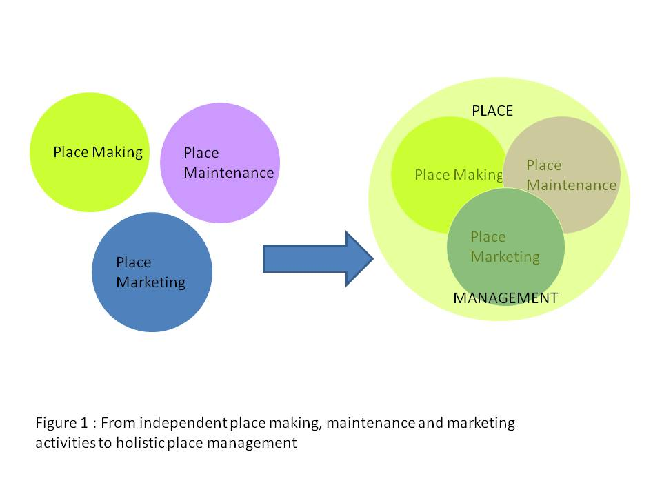

Until the mid 1990s, place management research was focused on town centre management in the UK, and was ‘marketing-centric’ . Then, researchers started to look at other models of place management in urban areas, looking for instance at Business Improvement Districts (in the USA) and the operational role they play in place maintenance. Finally, a third wave of place management research started which concentrated more on the strategic and partnership apsects of place management (Figure 2, p6.). In parallel with this development has been a growing academic interest in the potential of branding as a strategic tool to guide place development and place communication; as a mechanism of building ‘bottom up’ unique identity that unites and empowers disparate stakeholders. Place branding is, “not only possible it is, and has been, practiced consciously or unconsciously for as long as cities have competed with each other” (Kavartzis, 2008). Nevertheless, the problems inherent in places, their complexity, in terms of many users and many stakeholders (producers) has led critics to argue that, “places and place brands are inherently different from product and product brands and the conventional branding models and approaches are insufficient” (Parkerson, 2007). Whilst place branding is a concept more frequently used and researched in the academic literature, it is not widely practiced. It remains a concept rather than, place management, which is empirical. This is reflected in web traffic (see Figure 3, p.7) and web sites. Google searches for the terms “place management” and “place branding”, undertaken on the 30th November 2011, returned 733,000; and 375,000 results respectively.
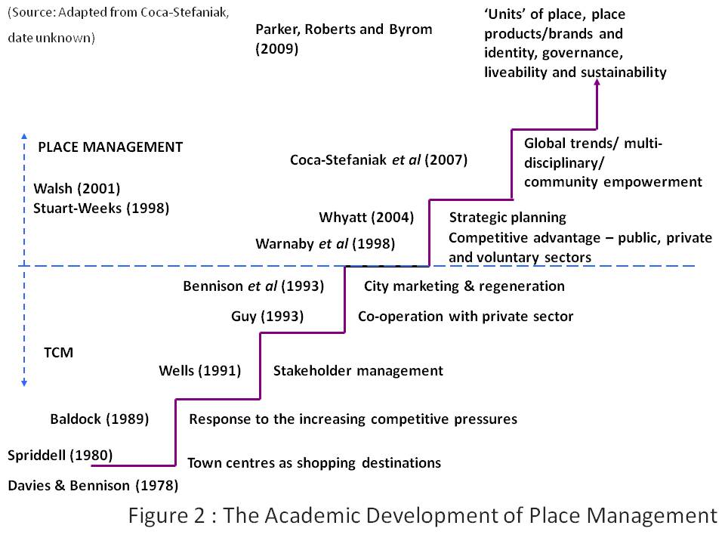
There is some geographical variation in the usage of terms. Whilst place management remains the dominant term to describe partnership approaches to place improvement, place marketing and place branding is also used heavily in some countries, such as Malaysia (see Figure 3, p.7), to describe the same phenomenon. There is a recognised need to clarify concepts and terms (Papadopolous, 2004, Kavaratzis, 2005 and Skinner, 2008) and also harmonise research and practice (Parker, 2008).

2.3 Purpose and process of place management
For the requirements of this report, it is the purpose and process of the activity (be it called management, marketing or branding) that is important. Therefore, the term place management is utilised, but place management is undertaken under other ‘labels’ and readers should be aware of this. The purpose of place management is to make sure places meet the needs of their users both now and in the future, with respect for the past and maintain/develop uniqueness and a sense of identity. The process of place management is through partnership.

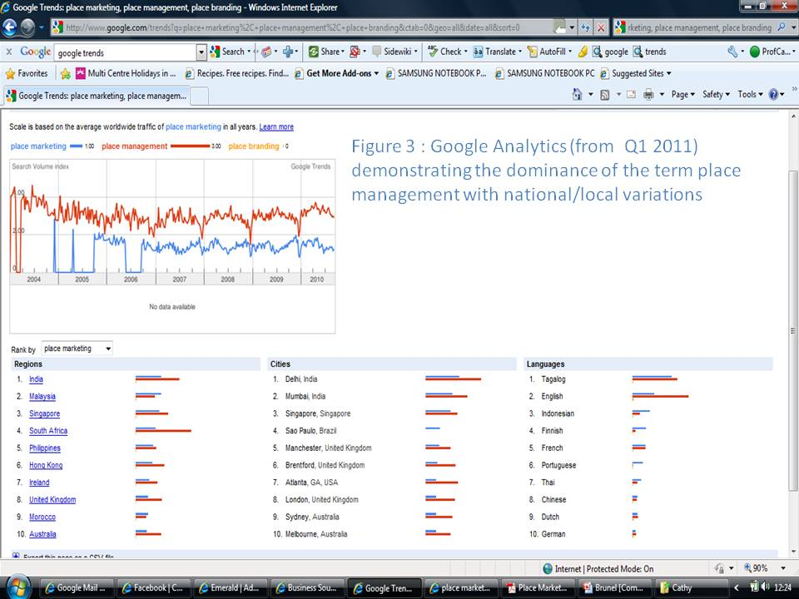

3. Environmental Analysis
An environmental analysis of place management has been undertaken at macro, meso and micro levels. As the report aims to provide an international review, then it is global factors that impact upon place management that have been included. Place management is a worldwide phenomenon. A recent internet review by the Institute of Place Management identified countries that had individual place management schemes (with an internet presence). Thirty seven countries were identified by this method (see Figure 4, p. 8). The various political, economic, social and technological factors that have fuelled the adoption of place management in individual locations are reviewed in the next section.

3.1 Political Drivers
Due to the ‘silo-ed’ nature of government (at all levels) and the difficulty in coordinating activity across a number of unconnected organisations, departments, agencies and individuals, many improvements to locations have ridiculously long lead times. There is a, “perception of governments and public services as siloed, aloof and out of touch” (Adams, 2008; p.17). This is particularly so in Europe and in countries which have a long and complex history of government. Just as the joined up government movement, “seeks to coordinate the development and implementation of policies across government departments and agencies with the aim of addressing complex social problems” (The Oxford English Dictionary) so place management seeks to coordinate the resources and activity across various stakeholders to solve place problems and make place improvements in a far more ‘holistic’ way. The way it does this is country-specific and may depend on the stage in the political lifecycle.
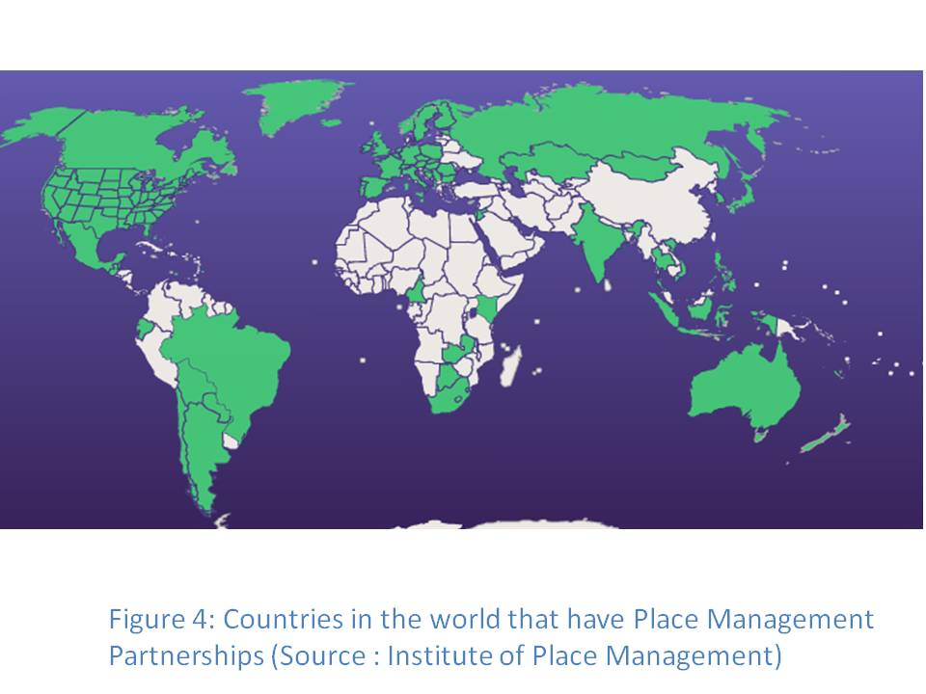
For example in newer democracies, such as the post-soviet states, the government structures are also new. Because of this the structure of government (at state, regional and local level) a) reflects the modern-day reality of the places they are managing and b) the ‘consumers’ of government are more familiar with the organisational structures and navigating their way around them (as the development of those structures has been within ‘living memory’). Some countries, such as Croatia, have purposefully set up ‘city districts’ to facilitate the management of very local areas. In this respect, there is no need to augment or challenge the existing model of government as local government is accessible and place-focused. Other more established nations have also attempted to restructure government to be more locally-responsive, with Scandinavian countries such as Sweden, Norway and Denmark adopting a philosophy to put local service provision back in the heart of local communities. Nevertheless, this is only a limited view of place management, as it just concerns partnership across government departments and other public bodies.
Like Croatia, other post-imperial nations have had the ‘opportunity’ to develop new forms of government, but not in living memory. Many such countries such as the USA and Australia have adopted a federalist system of government. As this system has devolution of power at its very heart, it is hardly surprising that ‘place management’ has been supported politically, devolving powers to city and district centres. In the case of the USA, the legislative environment is one that facilitates the development of place partnerships, through the creation of Business Improvement Districts. In Australia, many Mainstreet and activity centre managers have been appointed by councils to facilitate place partnerships.
Nevertheless, there is an overarching political trend that has driven the growth of place management partnerships, outside of the drivers within individual nations and that is the global trend of neoliberalism.
“Neoliberalism is in the first instance a theory of political economic practices that proposes that human well-being can best be advanced by liberating individual entrepreneurial freedoms and skills within an institutional framework characterized by strong private property rights, free markets and free trade”
(Harvey, 2005; 2)
Whether one is critical of the ideology or not, “we live in the age of neoliberalism” Saad-Filho and Johnston (2005;1) where the state is contracting, and society is ordered around indviduals being, “free to choose” (Friedman, 1980). The increase in public services being provided by private organizations or public-private partnerships has led to, “a more savvy public demanding more localised and responsive services and engagement with governments and the public sector” (Adams, 2008; 17). At first glance, this public need for engagement appears at odds with its disengagement with traditional forms of influence, such as local elections. Even at national elections, worldwide voter turnout has been in steady decline since the 1980s (in countries where voting attendance is non-compulsory).
In the UK, town centre management (a form of place management) is an example of a neoliberal response to rising expectations and a lack of engagement in government. At least 700 towns and cities operate under some sort of place management partnership scheme (Figure 5; p.10). These schemes are nearly always a partnership between the public sector and the private sector and exist to achieve economic benefits – all characteristics of neoliberal practice. Ironically, they have been set up to counteract other neoliberal forces, such as the deregulation of planning and the growth of out-of-town retail development.

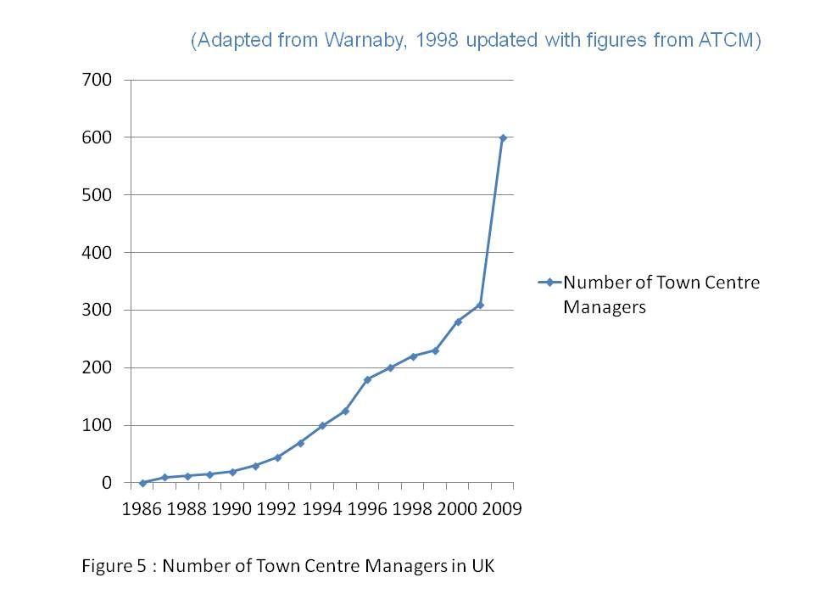

3.2 Economic Drivers
“Perhaps, somewhat paradoxically, the reason for the rediscovery of place as a focus of government, academic and industry interest is the globalisation of world economy and culture”
(Hall, 1997: 62)
Increasing concentration in the retail sector and the globalisation of the property sector has led to the homogenisation of places. Places compete to be ‘world-class’ but world-class usually means exogenous development – attracting inward investment, tourism and international architects to reinvent places. The organisations behind these activities are understandably externally focused and look to what other places are doing, rather than being more internally focused on endogenous development. This has led to the criticism that places are becoming more uniform and ‘packaged’.
“...contemporary architects, designers and other place makers, with their penchant for the postmodern, are as responsible for the commodification of place”
(Hall, ibid: 90)
But in some areas this has led to a revival of endogenous development as places themselves are a factor in terms of productivity and innovation. Silicone Valley is a much-quoted example of cluster theory (Porter, 1998) that results from the many different parts of the supply-chain of an industry being co-located. Likewise, in places like Paris, many different competitors, in a small geographic area can interact, share ideas and get artistic inspiration from what is going on around them. The recognition that place is, “a factor of production” (Adams, 2008; 17) has meant a more concerted effort to manage some places, to encourage the growth of certain industries, rather than just leaving it to chance.

3.3 Social Drivers
In 2020 the number of people travelling internationally is forecast to reach 1.6 billion and the resulting revenue is expected to exceed US$2 trillion (Kotler and Gertner, 2002). Destinations compete not only for tourists and delegates etc. but also for relocating companies and often a skilled workforce (Hospers, 2004). This, combined with the global trends of urbanization means many communities are becoming more transient and/or more diverse. Therefore, community well-being, capacity–building and cohesiveness are also outcomes that may need ‘a helping hand’ – through some sort of place management initiative. In Australia, place management is often synonymous with community development. This is not surprising given the rapid growth of multi-cultural immigration over the past 50 years.
Another global social trend is the growth of one-person households and the increasing amount of time people spend involved in non-social activities. Many places, not just those that have changed their population mix through immigration and/or large-scale expansion are having to facilitate the development of community, as the family or social ties that usually make up the fabric of community are becoming so much weaker.
To combat an increasingly globalised marketplace there has been a rise of consumer interest in local products and alternative retail formats, such as farmers’ markets. Interest in local heritage is increasing, fuelled by the growth of people researching their family tree and also, in some part, by a need to belong in communities that may not have been a lifelong home. Again, this results in an appreciation for and often involvement in, initiatives that ‘make a difference’ at a local level, such as the Australian Tidy Towns network.
Finally, changing demographics mean that the world’s richer nations have an ageing society. In Japan, for example, place management principles are being utilised, “to construct a compact city, and to integrate residential, commercial, office, and cultural functions along public transport lines” (Muraki and Sunaga, date unknown). Normally the exclusive domain of planning, the construction of the ‘compact city’ relies on many government departments and other agencies/organisations working together far more effectively.

3.4 Technological Drivers
An interconnectiveness based on technology also helps support people that are interested in their towns and cities.

In the UK, the magazine entitled The Idler started to collect comments from its readers about the places they lived, called “Crap Towns”, this culminated in an index of the 50 worst places to live in the UK. This is a typical view of three contributors:
“There is nothing in Wick except sullen faced youths hanging around chip shops and denim clad drunken tinkers who talk to cider bottles. There is nothing to do except drive cars for no reason other than to make their tyres squeak with handbrake turns. Everybody in the entire town has snot hanging from their noses. It has a river full of shopping trolleys.
The best thing about Wick is the lighthouse built by Robert Louis Stevenson’s uncle. Aged 17, RLS was in Wick and hated it. He ended up living in Western Samoa because geographically it was the furthest point from Wick on any atlas.
They have an amusement park in Wick. It is called a field. Their only export is Caithness Glass – most of which the factory buys from Accident and Emergency on a Friday night”
http://idler.co.uk/category/crap-towns/
The ease with which views can be posted and shared on the internet can be a powerful force for change. For example, the Crystal Palace Campaign, in London, has successfully used the internet to prevent a 20-cinema multiplex from being built on the historic, Grade II listed site in Crystal Palace Park. The internet availability of local statistics and place key performance indicators relating to the performance of local schools, crime figures, property prices, amenities etc, gives local people more information and data to challenge those that have historically been in charge of places. For example, a suburb of Liverpool, has formed an action group, a coalition of local residents, SMEs, schools and churches to successful challenge a planning application by Sainsburys, one of the UK’s ‘Big Four’ supermarkets that proposed to build over the existing village centre and develop their own vision for the future (A Better Crosby, 2011).
Whilst technology can support the engagement of individuals into place management, it also serves as a threat in terms of new forms of competition. Global internet sales are rising. Nevertheless, the retailers that are most a risk from e-tailing are those that also compete in terms of range, price and convenience but cannot ‘outcompete’ on-line selling in these areas, in other words, big box, out-of-town retail developments. Retailers and retail areas that compete on or build in an experiential dimension are not so threatened by e-tailing. Many retailers and retail areas have adopted a ‘clicks and mortar’ strategy where internet selling can complement the experience of physical interaction with the product.
Of particular relevance for this report is the potential that place management offers in terms of making multi-faceted places. Or, in other words, places that give people lots of reasons to be there: For retail, leisure, culture, education, health, working, and especially living. As more people movie into cities, urban areas are becoming increasingly multi-use. This helps negate against global trends that may cause the decline of a certain type of visitor (such as a ‘shopper’). The Internet cannot compete with a full place-experience, which offers people public and social services and ‘space’ for important past-times such as mixing with friends as well as shops and commodified services.

3.5 Meso level drivers
The macro-environmental trends discussed above put increasing pressure on places to adapt. In addition, to the macro-level pressures, places are also in competition with each other. As already mentioned, this has led to the application of business and management principles to places. Marketing ‘gurus’ urge places to, “learn how to think like businesses, developing products, markets and customers” (Kotler, Haiden and Rein, 1993: 346). Within a district, streets or malls may compete with each other; within a city, areas compete with each other (such as different shopping districts); within a region cities/towns compete; globally nations may compete. There is a complex place hierarchy. The rationale of place competition is compelling and urgent; places are encouraged to accept the principle, the implication being, if they do not, they will be ‘left behind’ (Gertner and Kotler 2004). Place competition fuels, “... the idea of togetherness in defense against a hostile and threatening world of international competition” (Harvey, 1989).

But what are places competing for? Lever (1999) identified mobile investment (from tourists, conferences etc.); Gross Domestic Product (from relocating firms); population; public funds and hallmark events (such as Formula 1 or Capital of Culture, for example). Some authors warn that the competition rationale might be detrimental to places, and encourage public bodies to spend scarce resources in the wrong way (see, for example, Pike, 2007). “Local authorities should shift their focus from cold to warm city marketing: they should invest in existing residents and firms rather than in newcomers” (Hospers, 2010). General marketing has moved away from the transactional and into the relational (Gronroos, 1997). Customer loyalty is encouraged as it costs more money to attract a new customer than keep an old one (Berry, 2002). Place marketing activity appears to lag behind as it is mostly aimed at attracting new investors, residents or visitors (Hopers, 2010). The bodies that undertake the activity are segmented too. Many nations, regions and cities have separate tourist boards and inward investment agencies, all undertaking place communication. The outcome has led to a, “forest of logos, slogan and messages” (Power and Hauge, 2008) and little evaluation of their effectiveness or collective impact upon a place. Place management offers an opportunity to harmonise external efforts and ensure that they are in the place’s wider and long-term interest.

As well as encouraging competition, another fundamental feature of a neoliberal philosophy is the retrenchment of state. Development controls are seen as unnecessary interference – and that the free market is the best mechanism to control development. In the UK, despite a ‘town centres first’ policy, the government is radically simplifying its planning policy framework to speed up development. The UK, like other countries such as Japan, previously used legislation to curb out-of-town retail development as it had such a detrimental impact on town centres. A new out-of-town development becomes a new entrant into the competitive marketplace thus making more competition, if the traditional town centre suffers, then surely it is just because it is not serving the population’s needs so effectively? According to a report by research firm CB Richard Ellis India, over 6 million square feet of retail mall space was added across India in the first six months of 2011 alone; primarily due to aggressive expansion by retailers. In this ‘free for all’ not everyone is successful. Cannibalisation is an accepted economic consequence of retail growth strategies but they also have other negative unintended consequences. Dead malls are not maintained, they are costly or impossible to redevelop (into other usage), they are unattractive and a physical symbol of decline or failure in an area. In addition, there is a huge, unnecessary, environmental cost associated with unsuccessful development. There is an environmental argument for protecting the status of traditional retail areas as they already have buildings and, more importantly, infrastructure, such as public transport links, roads and other services, which is very costly to develop (and usually financed or at least subsidised by public funds).
Loyalty (or the lack of it) may explain why so many traditional retail areas suffer when they are opened up to new forms of retail competition, such as out-of-town or internet retailing. Customers are not loyal to the place. This is hardly surprising as many of the factors already reviewed in this report are leading to homogenised retail areas or the ‘clone town’ concept. The commodification of place transforms people into place consumers, language which has been utilised throughout this report, when in actual fact, in successful places people ‘co-create’ the place, through their civic pride and high level of place attachment. Place management is a mechanism that should foster place loyalty and ensure that they can contribute to the ‘activation’ of the place. In the Granollers case-study presented further on in this report, the town centre management scheme encourages public debates as part of its remit as well as huge annual lunches for its citizens. Encouraging loyalty will also help ‘futureproof’ the place, in relation to new trends and challenges. The cost of fuel and the health cost of a sedentary lifestyle are both set to rise in the future. This provides traditional centres with an opportunity as people may not be able to afford to travel to other locations and may begin to demand ‘healthier’ modes of access to local centres, such as paths and cycle lanes. The provision of these alternative methods of transport is something that many place management schemes are already actively engaged in.
In conclusion, existing conceptualisations of place competition focus upon extraneous rewards that have to be ‘won’ or ‘attracted’. But what about developing the potential of a place from within? In other words, seeking endogenous rewards through, “prioritising cooperation and networks over competitive strategies” (Kalandides, 2007). Encouraging the start-up and growth of indigenous firms, loyalty from existing place users, etc. are all future directions for place management activity, which have already been practised in some locations (for example, the Granollers Loyalty Card). Because of this nested nature of places, ‘place co-opetition’ (Pasquinelli, 2009) may be a more meaningful phrase. For example, shopping streets or malls may be in competition with each other in a specific shopping district, but need to collaborate to position themselves as a viable shopping district and districts need to collaborate at the level of city management, etc.
Driver | Strength, valence and interest | Justification
Political | Medium driver of BID | Globalisation of neoliberalism impacts upon Singapore Government as international businesses expect to have more involvement in decision making. Political culture in Singapore is likely to favour formal over informal place management schemes and ones whose remit is clearly stated and operational rather than strategic (i.e. BIDS).
Economic | Strong driver of ‘status quo’ | The rapid modern growth of the Singapore economy, its favourable location in relation to other expanding economies makes it attractive to investors. The international concentration of the retail sector and the property development sector means that many businesses and property owners in the Orchard Road area have only a loose attachment to the place. It is difficult to encourage these ‘arms-length’ stakeholders to participate in informal place management partnerships. Likewise, they are also unlikely to be supportive of levies or other schemes that eliminate ‘free riders’. Given that many stakeholders in the area are there for economic reasons, they are free to relocate, if they perceive another area as more profitable. This may be perceived to be a more certain alternative than investing into place management in the area.
Social/Technical | Weak driver of strategic place partnership | The growth of internet retailing and changes in consumer behaviour mean that, increasingly, people visit traditional retail centres for experiential reasons. Consumers see places in a holistic way, retailers often do not. The changing nature of the consumer and their higher expectations of place should be a strong driver to encourage businesses to work more effectively to manage the whole place experience. To do this effectively requires vision and leadership,
Competition | Strong driver of BID | Planning policy is pro-development, therefore the retail landscape is very dynamic, meaning places compete for fascias and consumers. In addition the size of Singapore and its transport infrastructure facilitates place competition. As other areas adopt a more coherent approach to promotion and management then Orchard Road will need to do the same.

3.6 Micro-level factors
“As towns and cities across the world evolve due to pressures both local and global we are seeing more forms of management in a valid attempt to take a proactive approach to change to ensure locations meet the needs of their users in a more sustainable fashion”

(Parker, 2008b)

In this section the internal factors common to place management partnerships, globally, are summarised. This section has been written using the evidence collected from the Institute of Place Management Global Survey. The analysis is structured by McKinsey’s 7S’s of organisational characteristics. In addition funding is also added as an important internal factor.
Strategy - place management partnerships are mission driven. They are formed in response to social or economic problems; the most common being the threat of out-of-town retail development, town centre decline, unpopular town centre development or behaviour (such as that associated with the night-time economy), perceptions of increased crime, social deprivation and global problems such as unfair trade and global warming. The ability of partnerships to grow, to engage more stakeholders and take on a wider remit is influenced by its ability to produce ‘quick wins’. In other words, if progress is not forthcoming quickly in terms of tackling the problem that united people in the first place, momentum and then interest is lost. For the more established partnerships, there is little difference in the activities undertaken by the place management initiative (the most common activity is “planning/managing/delivering projects and events”) all under the umbrella objectives of making area improvements, attracting new businesses, increasing footfall and general marketing.
Structure – they are always partnerships as the strategy cannot be achieved by one body alone. Nevertheless, the degree of formality of the structure differs. Some place management partnerships are separate legal entities or have autonomous status within local government, others are more of a ‘coalition of the willing’. Nevertheless, over time the informal groups do seem to formalise, as their mission may widen as they take on more responsibilities (Coca-Stefaniak et al, 2009). For the formal partnerships, they tend to report to a board with a Chairperson, although the Chairperson is more likely to be an Elected Member or public sector employee in Australia. In both the UK and Australia the structure of the place management partnership is likely to be either part of the local authority/government department or agency or a partnership “with no legal format” (63% and 75% respectively). This compares to 75% of Swedish partnerships which are either privately-funded companies or cooperatives (i.e. they are separate legal entities). Irrespective of their organisation or reporting structure, the area initiatives cover is very similar, with most managing areas of less than 4km².
Systems – these are the daily activities/ procedures that the partnership engages in, to accomplish its strategy. Diary analysis has been undertaken with a variety of place managers, worldwide, and the general allocation of their time remains remarkably constant, regardless of the location, scale or scope of the partnership.
Administering the structures and day-to-day running of the partnership is time-consuming, as place managers are in many networks, even dealing with email correspondence is difficult due to the volume of email traffic.
Shared values – Place management partnerships are value-led organisations. Like other social enterprises/movements they tend to be based on the values of self-help, self-responsibility,
democracy, equality, equity and solidarity. Many place management partnership are driven by values related to social justice, fair trade, concern for the environment, social inclusion, gender equality and community cohesion. Nevertheless, partnerships which are dominated by one
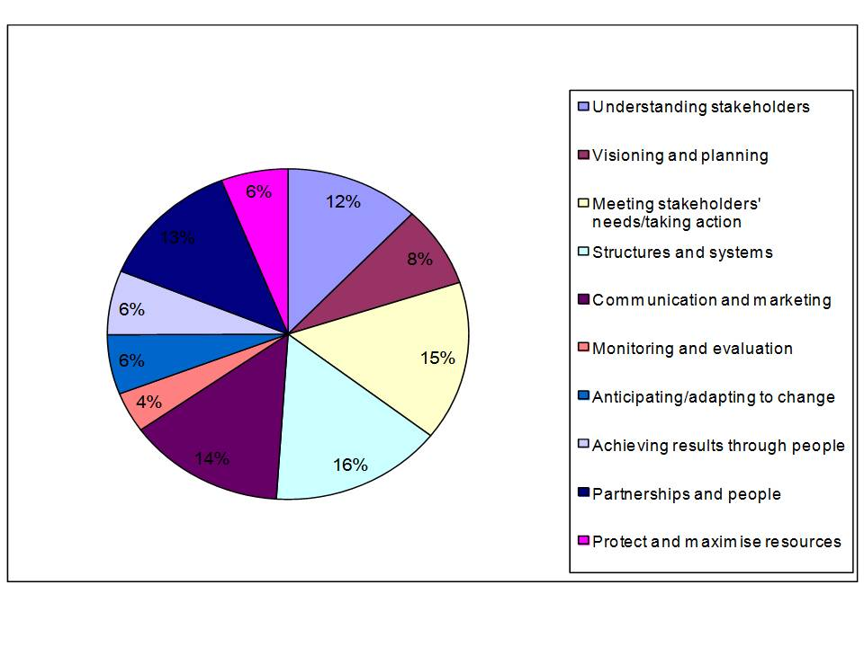
Figure 6 : Place management activities (time allocation over one week)
stakeholder or one type of stakeholder may not reflect such diverse values. In fact, often these partnerships adopt the same culture as the dominant stakeholder – in effect they are just subsidiaries of another organisation. This can be frustrating for other partners, for example a public-sector culture is associated with much more bureaucracy than private sector employees are used to.

Style – The dominant leadership style is facilitatory. Facilitatory leaders bring people together to solve problems and to share ideas, responsibility and leadership. This is hardly surprising as many people that place managers need to ‘get round the table’ are not under their control, in line management terms, as they may well work for a completely different organisation. The Institute of Place Management expects all its members to abide by a code of conduct which:
- Supports people making places the best they can be both now and for the future
- Respects diversity in both individuals and locations
- Encourages openness, honesty, trust and support for each other
- Honours integrity and high ethical standards
- Demonstrates leadership by example at all levels

(Source IPM: http://www.placemanagement.org/default.asp?a=content&id=559)

Staff – On the whole, place management partnerships employ a small core team (less than 6 people) but there are national variations. For example, 83% of Australian and 79% of UK initiatives employ less than 6 people with 87% of Swedish initiatives employing more than 6 people. As explained above, many of the human resources place management partnerships rely upon are not within the span of line management control of the place manager. This might be because other key personnel work in different organisations in the partnership or may be community volunteers. This means that place managers have to use their powers of persuasion and effective place managers tend to have engaging and charismatic personalities.

Skills – As an emerging concept place managers have had no specific training. Many have come from component industry backgrounds (such as community development or retailing). Our studies have found that the employment history of place managers is very varied and their educational attainment varies. UK and Swedish place managers have lower levels of educational attainment compared to, for example, their Spanish and Australian counterparts. Currently, place management qualifications are available in the UK, Poland, the USA and Australia. The lack of experience and, sometimes, low level of educational attainment may be a contributory factor in terms of ‘constraining’ the development of place management partnerships. A criticism of town centre management, in particular, is that it is only concerned with operational issues, so called “hanging baskets and Christmas lights”. It is unlikely that a partnership can break-out of a more operational ‘mindset’ if its employees do not have the conceptual skills to tackle more strategic issues.

Funding - Place management organisations rely on a wide range of income sources, but there are some national variations. For example, 25% of Swedish initiatives are fully funded from the private sector, compared to 16% of Australian initiatives and only 3% of UK initiatives. Some initiatives operate a membership scheme (89% of Swedish initiatives compared with 63% of Australian schemes and only 48% of UK schemes). In terms of turnover all countries were similar (average between $100,000 and $200,000 AUD) but 29% of Australian and 28% of UK initiatives did not allocate any of this to staffing or overheads (usually because these costs were paid by a public sector partner). In comparison ALL Swedish place partnership staffing and overhead costs are funded through their membership scheme. Some place management partnerships are linked to a certain type of funding. For example, Business Improvement Districts are funded through the business levy they charge (like the Swedish schemes). The difference with BIDS in the USA, UK and other countries they operate in (such as South Africa and Australia) is that contributions are mandatory, businesses cannot ‘opt-out’ of membership, thereby avoiding the problem of ‘free riders’.

4. Towards a typology of place management

In their review of different place management schemes in Europe, Coca-Stefaniak et al (2009) identify two factors by which place management initiatives can be categorised. Firstly, by their level of formality (e.g. does the scheme exist as a separate legal entity to other bodies, such as the local council?) and secondly by their sectoral affiliation and funding (is the scheme predominantly privately or publicly funded?). A figure showing the classification of different towns/cities is presented in Figure 8 (p.19), including the four case studies (Springfield, US; Granollers, ESP; Tamoya City, JAP and Darwen UK) further elaborated upon in the next section.
In addition to the source of funding and the level of formality in the partnership, its position in the partnership lifecycle is also a useful factor in categorising partnerships. Previous research (Communities and Local Government, 2008) has identified three main aims of place management partnerships and these are displayed in Figure 9 (p.20). The three aims are operational (delivering products and services, such as street-cleaning, place promotion etc.); political (influencing strategy that affects the place) and strategic (developing strategy and plans for the area).

5. Case-studies

5.1 Springfield, USA
“Springfield is the urban, economic, and cultural capital of Massachusetts' Connecticut River Valley, (colloquially known as the Pioneer Valley). It is the third-largest city in Massachusetts and fourth-largest in New England (Boston, Worcester, and Providence are larger). Springfield has several nicknames – The City of Firsts, because of its many innovations; The City of Homes, due to its attractive Victorian residential architecture; and Hoop City, because basketball – currently the world's second-most-popular sport – was invented in Springfield” (Wikipedia). The City of Springfield has a population of 153,060 (US Census, 2010).
Issues faced by the Springfield downtown area were similar to many other US downtowns, lack of investment, poor aesthetics, declining footfall, but the most serious issue was a significant rise in violent crime.
“Established in 1998, the Springfield BID (SBID) has been providing cleaner streets and sidewalks, more attention to the aesthetics of downtown parks and historic buildings, and care for new and existing trees, shrubs and flowers. The BID includes 235 properties assessed at over $300 million and their yearly revenue ranges from $750,000 to $800,000. The Springfield BID is a coalition of property owners, tenants, City officials and other groups with a stake in Springfield's success, and includes an 11-member Board of Directors. Other activities include helping to hire
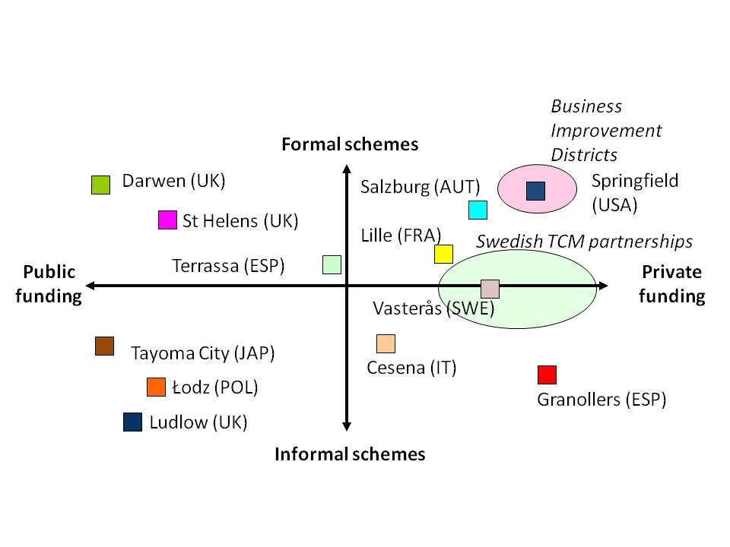
Figure 8 : Typology of Place Management Partnerships
private duty police officers, marketing the downtown, producing concert series, and financially
supporting the 4th of July fireworks and Holiday Lighting events. Between 1999 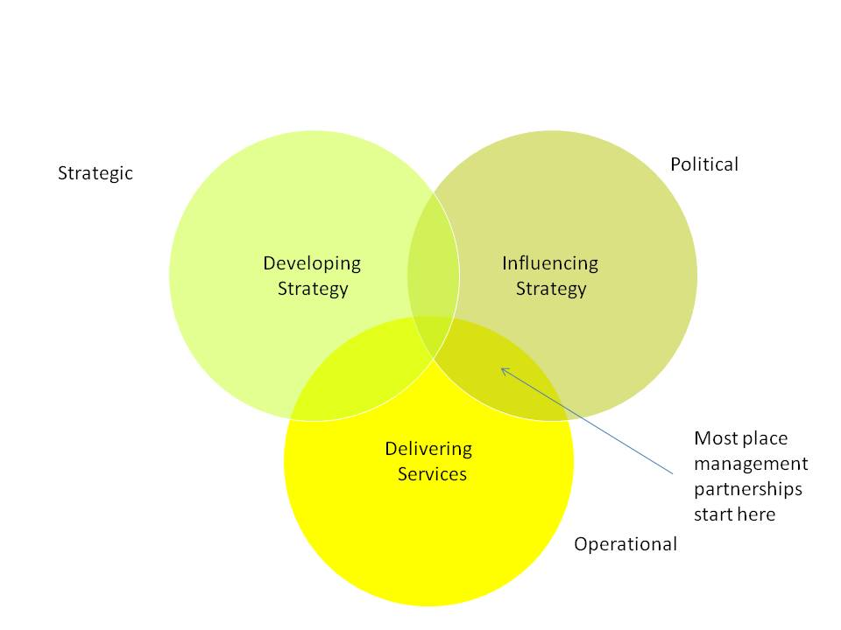
Figure 9 : Aims of Place Management Partnerships
and 2006, assessed values in the district climbed 54%” (Springfield Bid, 2011). The vision of the Springfield Business Improvement District is to improve the quality of life and revitalise Downtown Springfield through a focus on investment, marketing, economic development, special events and supplemental beautification, cleaning and security services. The goal is to increase property values and urban vitality by continuing to make the downtown a safe, clean, beautiful, friendly place to live, work and play. The activities of the SBID are listed below.
Clean Team – Litter removal; street and sidewalk sweeping; installation of hanging baskets; planter installation and maintenance; graffiti removal; sidewalk power washing; tree planting and maintenance; sidewalk replacement; snow removal.
Guides – providing directions to tourists; outreach to business; escorting visitors and employees; communicating with police through radio network; assisting the disadvantaged; giving change for parking maters; monitoring 30 downtown CCTV cameras; assisting police on downtown issues
Marketing – www.springfielddowntown.com; weekly e-bulletin to 2000; Facebook page with 1,600 fans; brand advertising on masslive.com; partnering with conventions and visitor maps; editorial and advertorial authoring; maintenance of calendar of events.
Events – Stearns Square Concert Series; Seasonal Farmers’ Market; Downtown Dine Around; Springfield Armour Games; Springfield Falcons Games; The Pancake Breakfast; 4th of July Fireworks; Parade of Big Balloons; Jazz Festival; Indian Motorcycle Day, Division II Basketball; Festival of Trees; Mummers Parade; Downtown Holiday Lighting; CityStage/Symphony Hall.
Economic Development – Assistance in business planning; investor and entrepreneurial outreach; consultation regarding historic and adaptive reuse possibilities; real estate sales and leasing support to connect users with owners and brokers; partnering businesses with financial programs, loans, incentives and tax credits; assistance in the business permitting, zoning and licensing process; maintaining comprehensive listings of all available real estate on internet.

5.2 Granollers, Spain
(Case study material from Coca-Stefaniak et al, 2005)
Granollers is a city with a population of 52,000 located 25 kilometres northeast of Barcelona in the autonomous Spanish region of Catalonia. The importance of Granollers as a centre for commerce grew in the Middle Ages, and the importance of its market is mentioned in chronicles dated in 1040 A.C. While there remains a very important role in the twenty-first century for retailers in Granollers, this sector of the economy has undergone considerable changes in the last three decades. These changes have taken place across Europe and have often affected small and medium-sized retailers through a combination of political, economic, social, technological, legislative and environmental factors. In Spain, some of these have been associated with important changes in customer behaviour influenced by issues such as immigration and social fabric change, the spread of large surface retail outlets and new lifestyle choices linked to a rise in the leisure economy and its association with shopping habits. As for Catalonia, and in spite of regional legislation introduced in 1997 limiting the development of large retail surface outlets, this autonomous region has witnessed a similar level of transformation in shopping habits among consumers. As a reaction to these challenges, various place management schemes have emerged both in Catalonia and all over Spain. However, unlike other European countries, where local authorities (e.g. United Kingdom) and chambers of commerce (e.g. France) have often played a pivotal role from the outset, Spanish TCM schemes have almost collectively evolved from a retail perspective, founded and led by small and medium-sized independent retail trade associations. Gran Centre Granollers is one of many retailer-led TCM schemes currently operating in Spain. Yet, unlike its contemporaries, this scheme has enjoyed a level of success among its stakeholders yet to be replicated by any other scheme in Spain. The association of small and medium enterprise (SME) retailers and businesses of Gran Centre Granollers was founded in 1994 by a group of independent retailers and led by Amadeu Barbany a fourth-generation local independent clothes retailer.

On 14th June 1995, at the association's first formal meeting with fifty founding partners, this vision became embodied in the motto of Gran Centre Granollers - "ciutat, cultura i comerç" (or “city, culture and commerce”). This vision was then translated into a set of fourteen operational objectives with the aim of having a clear set of goals to strive for and monitor. These objectives have been summarised in Table I.

Gran Centre Granollers operates with an annual budget of 312,500 Euros and a membership of three hundred SME businesses, which represents 75% of all the independent retailers located in the city centre of Granollers. The association, which has prided itself in its informality and inclusiveness, has nevertheless become one of the most successful trade association schemes and independently managed town centre management models in Spain.

The Gran Centre Granollers customer loyalty credit card was launched in 1995, soon after the creation of the Gran Centre Granollers Retail Trade Association, in cooperation with the Caixa de Galicia Bank. Based on a simple scheme, it has the following characteristics:

- 1. It does not charge the user any membership or management fees.
- 2. It does not require the user to open a new current account linked to the credit card.
- 3. Any purchase made with this customer loyalty credit card carries an interest-free three-month finance credit that allows the user to pay off the purchase over that three-month period in three instalments.
- 4. Other advantages (e.g. "bonus culture points", discounts in various shops and establishments, one-hour of daily free parking in the town’s car park, etc).

Membership of the card grew quickly since its launch and the card had reached a membership of 15,000 users, which renders it the second most successful credit card in the region by turnover after VISA itself. The card’s profits also make up the third largest source of income for Gran Centre Granollers at 13% of its annual budget after scheme membership fees (34%) and advertising income from suppliers and businesses (27%).

In line with its ethical code of practice, Gran Centre Granollers prides itself in having a well-established relationship with local and global charities. At local level, for instance, work has been done to support the "El Xiprer" shelter, which offers refuge to homeless people and other disadvantaged groups in and around Granollers.

Gran Centre Granollers organise many other social and cultural events throughout the year. These events, which tend to take place in the traffic-free areas of the “pedestrians’ islands”, include the following:

- • Live pop, jazz and folk music concerts.
- • Pupet theatre and other events for children.
- • Street lectures, open debates, conferences and seminars.
- • Open street debates as part of the "Agora" initiative (Figure 9) based on the original concept from Ancient Greece, where the agora was a place for people to meet, socialise, debate issues and trade goods.
- • Annual culture gala event.
- • Christmas party.
- • Carnival lunch.

There are various other initiatives that have been initiated and coordinated through Gran Centre Granollers, including an ambitious restoration of Granollers’ historical old town.

5.3 Toyama City, Japan
(Case study material from Muraki and Sunaga)
Toyama City is the capital city of Toyama Prefecture, and a major city in the north-west region, with 400,000 residents in 1200 km2. Of the issues that Toyama City faces, the local authority highlighted the following three points as fundamental problems: lack of accessibility for people without cars, the high maintenance cost of public facilities, and a less active and attractive town centre. The authority knows that the situation will worsen in the near future as the population declines and the rate of the elderly grows. In order to tackle these issues, the plan was to construct a compact city, and to integrate residential, commercial, office, and cultural functions along public transport lines.

The city centre residential population saw a 7% increase between 1980 and 2000; but the population in the suburbs grew by 34%, fuelling urban sprawl. Toyama City is highly auto-dependent: its auto dependency is at 72.2%, which is very high compared to the national average. The public transport system has developed its network from Toyama Station, and most rail and bus lines run from that station; however, public transport ridership has rapidly declined, and a number of services and service lines have been cut in recent years.

Accessible public transport can assist in the creation of a liveable town centre but it is not possible to construct a compact city through public transport alone. A number of Japanese cities have tended towards policy packages of regulation and deregulation; in comparison, Toyama City proposed market incentives while lacking the power of enforcement. It’s useful facilities, shopping centres, cultural interests and of course, transport systems are located within walking distance, if residents live in the town centre or along the transport networks. This is possible only if the land-use and public transport systems effectively work together. Therefore the purpose of the town centre partnership was to coordinate activity across local authority departments to tackle town centre revitalisation.

Even though the central government of Japan began enacting laws accompanied by grant programmes in the 1990s, concrete results have yet to be seen regarding the revitalisation of its town centres. Because of weak development controls, until 2006, it was difficult to stop the development of large-scale shopping centres that are located outside of town. In addition, population decline and the quality of life for the elderly are nationwide issues in Japan, and the high elderly rate and outflow of the labour population are particularly serious problems in small cities.

To address these issues in Toyama City, the inter-department partnership has focused upon:

- Promotion of the public transport system
- Network building between the town centre and district centres
- Keeping the frequent transport service lines
- Network building between the town centre and its community
- Housing the population along transport networks
- Ensuring that public buildings and residential developments are in close proximity to rail and bus stops
- Town centre revitalisation
- Providing good accessibility for public transport systems
- Offering an attractive central area
- Promotion of town centre living

As a partnership of existing departments within the local authority, the initiative has been funded through existing funding sources, with funding for the projects coming from State Town Centre Revitalisation programmes.

5.4 Darwen, UK
(Case study material from Fitzgerald and Coca-Stefaniak, 2004)
Darwen is an old Victorian market town located in the Northwest of England, near Blackburn and Manchester. Its town centre is very compact and lies within a valley with views to the surrounding countryside. Its size and location render Darwen a convenient town for people to shop, with affordable housing, excellent public transport links and a strong sense of community among its residents.

Like many other towns and cities across Europe, Darwen has been affected in the last two decades by adverse changes in consumer behaviour and a degree of apathy among its business community sometimes exacerbated by a certain level of local cynicism, which would see Darwen as Blackburn’s ‘poor relation’. Additionally, there is a growing need to regenerate the town’s centre physically and commercially with the aid of a stronger level of consensus between its resident community and the remaining town centre stakeholders.

Darwen Town Centre Partnership is a young town centre management scheme by British standards. It was created by Blackburn with Darwen Borough Council in January 2004 and, sixteen months later, gained approval for its current masterplan. A copy of the masterplan was circulated to every single household in Darwen for consultation prior to discussion at a public meeting. It is based on a Town Centre Strategy inspired by the opinions and values of the community and stakeholders, which also resulted from an extensive consultation process, which took place within the first few months of the establishment of the Partnership. In spite of its humble origins, with an annual budget of £20,000 with other in-kind support provided directly by the Council (e.g. hire of facilities, technical staff, publications and newsletters, displays and exhibitions), Darwen Town CentrePartnership has evolved into a fully operational town centre management (TCM) scheme in a record time frame.

Today, Blackburn with Darwen Borough Council still provides the scheme’s core funding as its lead organisation though, with the help of the council’s officers and a dedicated town centre manager, it has managed to attract considerable levels of external funding from other national and regional sources such as:

- • Heritage Lottery Fund – £1 million with identical amount of Council match funding.
- • Market town initiative – initially £150,000.
- • Liveability fund – £700,000.
- • Local transport plan – £500,000.

In-kind support continues to be provided by Blackburn with Darwen Borough Council through eight Council (Regeneration Department) and Capita (Council’s technical consultancy partner organisation) officers working a proportion of their time (at least 1 day/week) exclusively on issues related to the TCM scheme. All other physical resources (e.g. computers, office space, etc.) are also provided by the Council.

Although the Council is the sole provider of finance and resources for the TCM scheme at present, there are also other partners involved in the decision making process of this scheme. They include the police, community associations, Primary Care Trust, Civic Society, Darwen Business Association, local residents, employers’ forum, young people, local developer, markets, Groundwork and the old people’s welfare committee. All of these have representatives on the TCM’s steering group that sit alongside representatives of the Council.

In 2004-2005, a benchmarking study was carried out in Darwen for the collection of PPG6 key performance indicators in conjunction with a street survey, a market customer survey, and a business survey. When compared with similar town centres in the region, Darwen’s TCM scheme performed very well in most of its key performance indicators. Many aspects of the original masterplan have now been completed, including the Townscape Heritage Initiative, the new Darwen Leisure Centre and Health Centre and the arrival of a new college, the Darwen Academy. The partnership is currently working on developing its next long-term strategy.

6. Critical success factors

Although the purpose, funding and nature of the four case-study place management partnerships is very different, there are some common factors inherent in successful schemes (and some lessons that can be learnt from unsuccessful schemes).

6.1 Multiple stakeholders and true partnership

To be successful place partnerships have to represent all the stakeholders present in the area they manage.

Although as many as 197 Town Management Organisations (TMOs) started in Japan, “the initiatives had no involvement from the local authority or the community” (Quin, 2002). Likewise, many of the local authority led initiatives had little or no involvement from the business or resident community (such as the case-study example of Toyama City).

In the more formal models of place management, where the partnership has legal status then there can be more of a requirement for stakeholders to work together, nevertheless, many researchers have criticised the organizational structure of many BIDs as they only include business premises and, even within this stakeholder group, the weighted voting system usually, “devolves larger property owners more authority” (Hoyt and Gopal-Agge, 2007). This can be combated through the development of good governance (see below).

6.2 Good governance

Place partnerships need to develop a governance structure which is sensitive to the political environment whilst ensuring the mission is achieved and can ‘creep’ (if necessary).

The North American BID concept has been, “institutionalised at an international level” (Hoyt, 2006). In other words, across the world, BIDS have similar roles, strategies and organisational cultures. Likewise, the UK town centre partnership model was the one initially adopted by the Japanese Government but this has not been successful as these ‘foreign’ governance models are not necessarily sensitive to the national political environment that they operate in. Despite the globalisation of neoliberalism, some cultures are more centralised than others, and in centralised political environments, it is unlikely that BIDs can ‘grow into’ more inclusive and strategic roles, for example some BID boards in New Jersey (Freehold Center Partnership and the Union Center Special Improvement District) have granted residents voting power by including residents in the governing structure (Justice and Goldsmith 2006). This is unable to happen in the UK without a change to the national legislative framework governing BIDS.

The governance model adopted by a partnership depends upon, and needs to balance, three main factors: it has to be sensitive to the local and national political environment, it has to reflect the priorities of the funders (for example the regulations surrounding the use of public money) and it needs to ensure that the partnership achieves what it sets out to do. This is not easy and the failure of many place management partnerships can be attributed to poor governance. Governance needs constant review and the very ‘organic’ and responsive nature of place management means that effective partnerships ensure their governance structure suits their mission (rather than their aim being constrained by their structure). Granollers has now adopted charity status with the local authority having a formal role in the partnership, as the partnership has moved into regeneration projects.

6.3 Facilitatory and committed leadership

Successful place management partnerships have excellent place managers.
In order to build trust amongst stakeholders, place managers need to be ‘embedded’ in a place. They need to be committed to the place. Successful place managers build up credibility in a location from spending time there, getting to know its history and its people. People partner with other people, the contracts and paperwork may get signed by organisational representatives, but place management activity is conducted through goodwill and good working relationships between individuals. As there is no legal imperative in Japan for place management, it is only some government departments that are working in a more collaborative fashion. Even when place management partnerships have legal status, stakeholders cannot be forced to do anything other than that they are legally charged to do (such as pay their levy). A good place manager or a good place management team will foster partnership and accrue all sorts of ‘in-kind’ benefits which help achieve the mission.

6.4 Security of funding

Successful place management partnerships need to be financially sustainable from a mix of funding sources

It is an obvious point, but to achieve their mission, place management partnerships need funding and need to be able to plan for the future, with secure finances in place. Research on the town centre management model suggests that voluntary financing constrains their effectiveness because an inordinate amount of time is consumed by acquiring sponsorship and justifying the perceived benefits and costs to stakeholders (Reeve 2007). In the UK, the publically financed TCM schemes are suffering due to the squeeze on the public purse, those that have a BID are more secure, as they are not so reliant on public funds. With BIDs, the mandatory levy is seldom the only source of funding because BIDs, “are innovative fund raisers that typically rely on several sources of revenue to sustain their operations” (Hoyt and Gopal-Agge, 2007). According to the international survey of BIDs organizations, one-half of the BID managers in New Zealand (52%) and the United States (50%) reported that they received voluntary donations or in-kind contributions from tax-exempt properties in the district. Additionally, almost one-half of the BID managers in New Zealand (48%) and Canada (40%) indicated that they received financial support in the form of subsidies and government grants (Hoyt 2005).

6.5 Anticipate and adapt

Successful place management partnerships anticipate and adapt to change.

Many place management schemes have built up a successful local coalition and ‘grown into’ a more strategic role over time. Academic literature highlights their role in promoting residential development (Birch 2002), argues their ability to strategically advance retail (Gopal-Agge and Hoyt 2007), and emphasises their place-marketing component (Kavaratzis, 2008).

In contrast, some critics believe that place management partnerships are only effective for addressing the minor problems associated with urban decline (Lloyd et al. 2003). Like many Business Improvement Districts, Springfield is predominantly operational, delivering products and service to the area. This is fine as long as other agents are ‘taking up’ the more strategic issues associated with downtown decline.

Place management partnerships need to understand how and why places change and their role in the ‘partnership landscape’. Research conducted by the Institute of Place Management demonstrates how little time place managers allocate to ‘anticipating and adapting to change’ as they are often reactive rather than proactive. Many of the future trends affecting places are already known (increasing urbanisation, ageing society, adoption of the internet, rising oil costs, global warming, etc.) so places can be planning for the future, to shape their development in a far more proactive and positive way.

6.6. Pursue operational, strategic and political objectives

Both quick wins and long term change is important.

The Darwen case-study illustrated the ‘two-time frames’ that successful place management partnerships work within. In order to maintain enthusiasm the partnership has to develop some ‘quick wins’. It is likely to be hard for Toyama City to engage business stakeholders as the time-frame of the activity is very long-term, in other words it will take some time for anything to happen. In addition, a place management partnership is never going to have entire jurisdiction over an area, there are always going to be other bodies, especially state bodies, whose actions influence the development of the area (both positively and negatively). To reiterate the point made above, place management partnerships need to understand where they fit in the partnership landscape and lobby and influence other political players when necessary.

6.7 Place identity and uniqueness

Places partnerships should build a future that respects a place’s past and fosters its home-grown assets.

Paradoxically, increased place competition, or “place wars” (Kotler et al, 1993), encourages places to pursue strategies of so-called uniqueness and place identity that critics allege has created brand marketing campaigns that have led to a homogenous marketable image that, coupled with capital improvements that emphasise the implementation of uniform street furniture, create generic streetscapes which dilute the vitality of the areas they seek to revitalise (Caruso and Weber 2006, 205). The internationalisation of retail combined with the internationalisation of place management, and their supporting industries, is creating identikit places. To be world class is increasingly becoming a unifying design template creating the same place the world over. In Granollers and Darwen a lot of effort has been spent ensuring the vision for the future respects the past and builds on place assets and history. Many regeneration and development schemes fail because they lack any ‘endogenous’ glue. The regeneration of Manchester City Centre after the IRA bomb has pushed out all the indigenous retailing. National and global retail firms have less loyalty to the city centre than local businesses. In Granollers, the local retailers were prepared to ‘stay the course’ during difficult trading times, where their bigger counterparts would abandon an area if profitability fell below a certain level. Some authors (e.g. Warnaby) have posited that place management can learn a lot from the management of services, in particular the role consumers can place in the co-creation of place. The behaviour and actions of place user A can impact on place user B – so why not encourage people to play a positive role in place production as well as place consumption? During the Commonwealth Games in Manchester hundreds of local people volunteered and were trained to be place ambassadors, and it was the interaction with local people that many international visitors really appreciated.

6.8 Multi-facetted place benefits

Places should offer a bundle of benefits.
A place should meet as many human needs as possible. That is why different scale settlements started, to provide services that met various needs. In Europe, market towns developed as areas of trade, within a catchment that extended to a day’s walk. During the weekly visit to town banking was done, local taxes might be paid and news/gossip caught up on in the local tavern. Modern day places have become increasingly uni-dimensional, meaning there is only one reason to visit them. Successful downtown/city centre revitalisation in the USA and UK has extended place benefits to serve a growing resident population and new forms of business, especially creative industries. Where possible, public services should also be provided in centres, thereby growing their importance and multiplying the potential reasons to visit. The relocation of health and educational services to edge-of-centre and out-of-centre areas has proved catastrophic for many towns and cities.

6.9 Think coopetition not competition
Places need to foster collaboration
It is too simplistic and too detrimental to think of places purely in terms of competition. As it is, many stakeholders in a location already find it difficult to collaborate. People usually visit retail areas because there is a concentration of many retailers – not because of one particular shop. Retail operators are notoriously insular, therefore place management has to encourage more cooperation. In addition, place management partnerships need to work together at different levels (the city, the state, the nation) in the face of genuine place competition (to attract mobile investment, such as tourists etc.)

6.10 Places exist alongside and within other places

Be aware of spillover effects
Places are nested in a complicated hierarchy. It is unlikely that the actions of one place are not going to have an impact on other areas. One of the criticisms of place management activity is that it displaces problems, rather than solves them. For example, the installation of CCTV may have a beneficial impact in one retail area, in terms of reducing retail crime, because it is just displacing the criminal behavior to another retail area that doesn’t have CCTV.
The activities that place management partnerships engage in can help decision making at a broader level. After all, many place management partnerships are innovating and piloting solutions that can be rolled out on a wider scale. This can only happen is place management is well networked. The more publically funded initiatives are easy to network, in this way.

6.10 Successful place management is bottom-up and top-down

Sustainable place management is about strong local partnerships within a supportive policy framework.
This is the ‘nirvana’ of place management, and is most likely to be found in countries with a long tradition of grassroots movements, ‘kick-starting’ local partnerships, which have then been supported through successive policies and legislation (for example Canada and the US).
At both local and national level, successful place management takes time. Approaches cannot be transposed from one country to another ‘overnight’ or even from one place to another. They have to develop through organic enthusiasm, so that local people/businesses feel ownership and control. If they remain purely bottom-up approaches, they can be successful, but only if they engage public sector stakeholders in the longer-term (like Granollers) otherwise they are likely to be seen as a competitive nuisance. Purely top-down approaches are never successful as they are replicating the same problems inherent in other public bodies – i.e. a lack of engagement, a feeling of ‘aloofness’ and an overly bureaucratic culture.

7. Conclusion
This report set out to review place management. For years, towns, cities and other places have been planned, maintained, changed and marketed in a rather haphazard way. In many countries, government is not able to act quickly and engage with its electorate in a way that mobilises citizen participation in the way many local place management initiatives appear to.
Nevertheless, new forms of governance, in relation to place, need monitoring and evaluating. There are critics of some forms of place management, such as Business Improvement Districts. In the book “Ground Control” (Minton, 2009) the author argues that there is a creeping privatisation of public space and that place management initiatives which consist only of the private sector will not protect and enhance the social and cultural fabric of our towns and cities. Nevertheless, through the use of other company formats, such as not-for-profit companies, cooperatives and charities, public space could be managed in a more efficient way with a clear emphasis on meeting social, environmental or other non-commercial objectives. The management company behind Federation Square in Melbourne (Fed Square Pty Ltd) is an example of this (Sydenham-Clarke, 2009).
With a growing worldwide interest from academics and researchers in the subject, an ever-increasing number of place management initiatives being formed and widespread adoption of new forms of communication, such as social networking sites, place management has the potential to deliver benefits, both locally and globally as it offers a holistic view of an area and its people and new forms of governance and financing, through effective partnerships (Local Government Research Network, 2001). In conclusion, place management partnerships exist because they have to, in other words, they are fulfilling a need that other agencies and existing, individual organisations are not.

References
A Better Crosby http://abettercrosby.blogspot.com/p/plan-for-crosby-village.html (accessed 30/11/11)
Adams, D, 2008, Place management : Collecting Definitions and Interpretations, Journal of Place Management and Development, 1, 1
Berry, L., 2002, Relationship Marketing of Services--Perspectives from 1983 and 2000, Journal of Relationship Marketing, 1,1, 59-77
Caruso, G., and Weber, R. (2006). Getting the max for the tax: an examination of the BID performance measures. International Journal of Public Administration 29, 187–219.
Coca-Stefaniak, J.A., Parker, C., Barbany, A, Garrell, X and Segovia, E., 2005, Gran Centre Granollers – “city, culture and commerce", International Journal of Retail & Distribution Management, 33, 9, 685 - 696
Coca-Stefaniak, J.A., Parker, C., Quin, S and Rinaldi, R, 2009, Town Centre Management Models: A European Perspective, Cities, 26, 2, 74-80
Communities and Local Government, 2008, Managing Town Centre Partnerships: A guide for practitioners www.communities.gov.uk/documents/communities/doc/1017945.doc (accessed 3rd December 2011)
Friedman, Milton (1980): Free to Choose. New York: Harcourt Brace Jovanovich.
Fitzgerald, T and Coca-Stefaniak, A, Darwen Town Centre Partnership – empowering local communities through town centre management, http://www.placemanagement.org/default.asp?a=downloads&id=554
Gertner, D. and P. Kotler (2004). "How can a place correct a negative image?" Place Branding and Public Diplomacy 1(1): 50-57.

Gronroos, C., 1997, Value‐driven relational marketing: From products to resources and competencies, Journal of Marketing Management, 13, 5, 409-419

Hall, C.M., 1997, Geography, Marketing and the Selling of Places, Journal of Travel and Tourism Marketing, 6, 3/4.
Harvey, D., 1989, The Urban Experience
Harvey, D, 2005, A Brief History of Neoliberalism, Oxford University Press
Hospers,G-J, 2004, Place Marketing in Europe: The Branding of the Oresund Region, Intereconomics, 39(5): 271-279
Hospers, G-J, 2010, Making sense of place: from cold to warm city marketing, Journal of Place Management and Development, 3, 3, 182-193
Hoyt, L., 2005, Do business improvement district organizations make a difference? Crime in and around commercial areas in Philadelphia. Journal of Planning Education and Research 25, 2, 185–199.
Hoyt, L, (2006). Importing ideas: the transnational transfer of urban revitalization policy. International Journal of Public Administration 29, pp. 221–243.
Hoyt, L. and Gopal-Agge, D., 2007, The Business Improvement District Model: A Balanced Review of Contemporary Debates, Geography Compass 1, 4, 946–958.
Jacobs, J, 1961, The Death and Life of Great American Cities, Vintage Press.
Journal of Place Management and Development, http://info.emeraldinsight.com/products/journals/journals.htm?PHPSESSID=05p0rrasdi4idticmfq5i5ki45&id=jpmd (accessed 30/11/11)
Justice, J. B., and Goldsmith, R. S. (2006). Private governments or public policy tools? The law and public policy of New Jersey’s special improvement districts. International Journal of PublicAdministration, 29, 1–3, 107–136.
Kalandides, A. (2007). Marketing the Creative Berlin and the Paradox of Place Identity. Lo sviluppo territoriale nell'Unione Europea. Obiettivi, strategie, politiche. A. I. d. S. Regionali. Bolzen.
Kavaratzis, 2005; Place Branding: A Review of Trends and Conceptual Models, The Marketing Review, 5,4, 329-342
Kavaratzis, M., 2008, From city marketing to city branding: An interdisciplinary analysis with reference to Amsterdam, Budapest and Athens, PhD Dissertation, University of Gronigen, http://dissertations.ub.rug.nl/faculties/rw/2008/m.kavaratzis/?pLanguage=en&pFullItemRecord=ON
Kotler, P and Gertner, D, 2002, Country as Brand, Product and Beyond: A Place Marketing and Brand Management Perspective, 9(4/5): 249-262
Kotler, P, Haiden, D and Rein, I., 1993, Marketing Places.
Lever, W., 1999, Competitive Cities in Europe, Urban Studies, 26, 5-6, 1029-1044.
Local Government Research Network, 2001, Place Management What is it?, Proceedings of the LGRN Forum Strategic Approaches to Place, 7th June
Lloyd, M. G., et al. (2003). Business improvement districts, planning and urban regeneration. International Planning Studies 8, 295–321.
Mant, J, 2008, Place management as a core role in government, Journal of Place Management and Development, 1(1): 100-108
Minton, A, 2009 Ground Control, Penguin.
Muraki, M and Sunaga, D, date unknown, Town centre revitalisation in the shrinking age:
challenges to town and transport planning, Proceedings of Melbourne Knowledge Summit.
Parker, C., 2008, Place: The Trinal Frontier, Editorial, Journal of Place Management and Development, 1, 1,
Parker, C, 2008 (b) Foreword in Global Survey in Campin, S, Parker C, and Roberts, G (eds) in Global Survey Australian Report: Findings of the Place Management Area Survey, Institute of Place Management, Manchester
Parkerson, 2007, From schlock to hot: Shifting perceptions of Brooklyn, Editorial, Place Branding and Public Diplomacy, 3, 263–267
Papadopolous, 2004, Place branding: Evolution, meaning and implications, Place Branding, 1, 1, 36–49

Pasquinelli, C., 2009, Competition, Cooperation, Co-opetition. A conceptualization of the ‘Network Brand’, Paper submitted to the Regional Studies Association International Conference “Understanding and Shaping Regions: Spatial, Social and Economic Futures”, Leuven, Belgium 6th and 8th April
Pike, A. (2007) “Brands, branding and territorial development” Draft Paper for the Regional Studies Association ‘Regions in Focus’ Conference, Lisbon, 2-5 April, 2007 (http://www.regional-studies-assoc.ac.uk/events/lisbon07/papers/pike.pdf )
Porter, M., 1998, Clusters and the New Economics of Competition, Harvard Business Review, Nov-Dec
Power, D. and A. Hauge (2008). "No Man's Brand - Brands, Institutions and Fashion." Growth and Change 39(1): 123-143.

Quin, S., Japan’s town centres struggle in absence of UK style policies, Urban Environment Today, 16th May, p.12
Reeve, A. (2007). Town centre management: developing a research agenda in an emerging field. In: Morçöl, G., et al. (eds) Business improvement districts: research, theories and controversies. Oxford,UK:Taylor & Francis Books.
Saad-Filho, Alfredo and Deborah Johnston (2005): “Introduction”; pp. 1-6 in Alfredo Saad-Filho and Deborah Johnston: Neoliberalism – A Critical Reader. London: Pluto Press.
Skinner, H., 2008, The Emergence of Place Manrketing’s Confused Identity, Journal of Marketing Management, 24 (9/10), pp915-928
Springfield Bid, http://www.mass.gov/envir/smart_growth_toolkit/pages/CS-bid-springfield.html (accessed 2nd December 2011)
Stewart-Weeks, M, 1998, Place management: fad or future? A presentation to an Open Forum, Institute of Public Administration Australia (NSW Division). 20th September
Sydenham-Clarke, J, 2009, Federation Square, under review by Journal of Place Management and Development
Wikipedia, http://en.wikipedia.org/wiki/Place_management (accessed 30/11/11)

